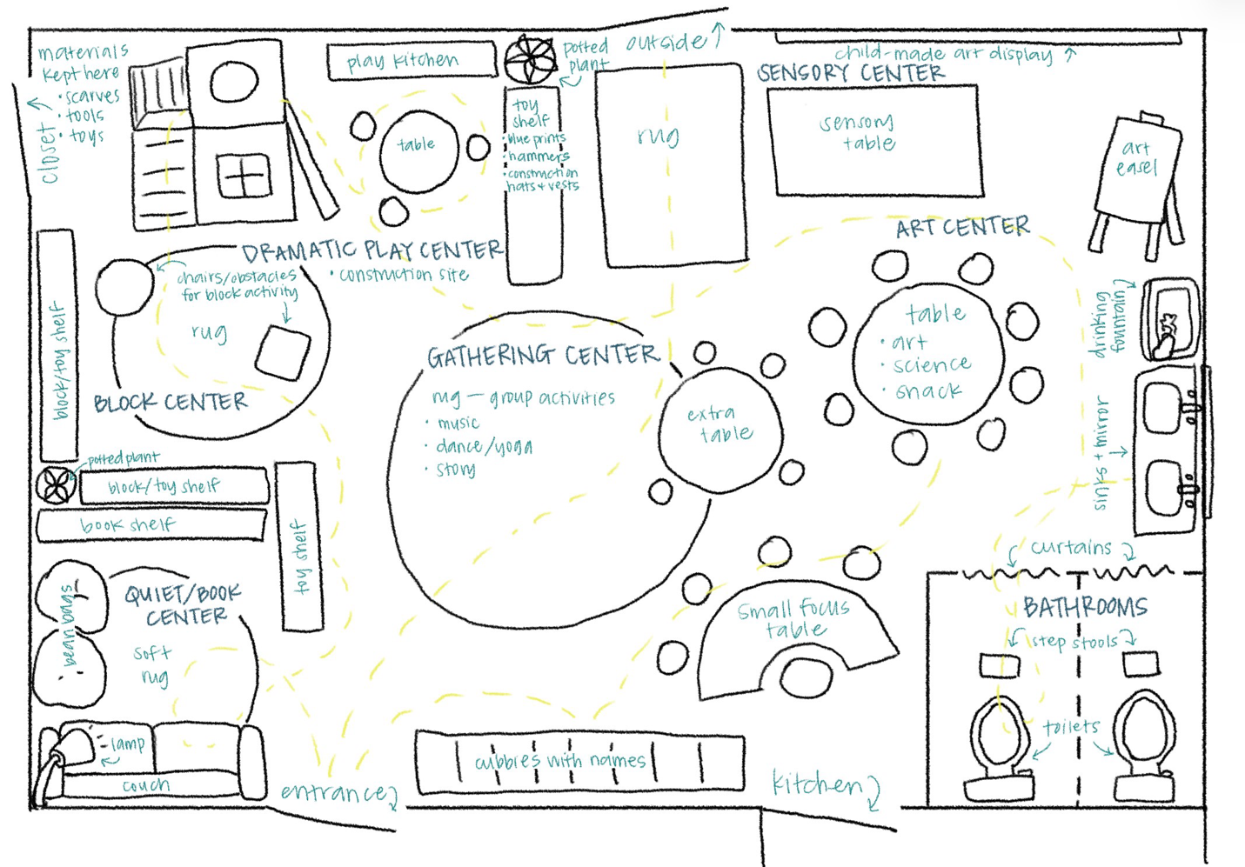
Classroom Layout Justification
I designed a classroom layout based on what I know of whole child development and the standards for early childhood classrooms. You enter the classroom and are immediately greeted by a wide-open space with a view of the whole classroom. To the right of the entrance are individualized cubbies for each of the children to put their things. The cubbies have their names on them to provide a sense of ownership and belonging. To the left of the entrance is the quiet reading center. There is a soft rug, a couch, and comfy beanbags for the children to relax and look at the books provided on the bookshelf. I also added a lamp to provide soft lighting and a plant to add some nature to the space and fill the gap created by the shelves.
Behind the bookshelves of the quiet area is the block center. I arranged the shelves back to back to provide a separation between the two centers and bring some privacy and quiet to the reading area. There is a rug in the block center for the children to play on. In the layout I included chairs/small furniture in the block area just for this lesson plan. Adjacent to the block area is the dramatic play center, with nothing separating them as they are often intertwined. The dramatic play center includes a climbing structure that can be used in a variety of ways (climbing, sliding, hiding, etc.) There is also a play kitchen with a table and chairs. There is another shelf that has the provided materials on it. Behind the dramatic play center is the materials closet (only for teachers).
Behind the toy shelf in the dramatic play center, there is a rug and passage to the door that leads outside. I made sure that there was a rug and ample space for the children to run in and out as needed. Beside the outside door is the sensory table and art center. I put the sensory and art next to the outside door because those are often messy areas and natural materials are often used. On the wall in this area is a space to hang children’s artwork. There is a large art easel and a large table with enough chairs for all of the children. This table is used for art projects, science, and snack. I purposefully placed the drinking fountain and sinks next to this area as well, as children will need to wash their hands for snack and messy activities. Right next to the sinks are two bathroom cubicles with toilets and step stools. Each cubicle is closed off only by a short curtain, to provide privacy and safety for the children. Next to the bathrooms is a door to the kitchen, where food is prepped for snack and cooking activities. I placed it here so it would be close to the snack table and the sinks.
There is a curved table that slightly blocks the kitchen door so that children don’t wander in there. The table is used for small focus groups and has one side where a teacher would sit and a few chairs on the other side for the children. In the center of the room is a large rug. This empty space acts both as an open, accessible passage to areas throughout the room (as demonstrated by the dashed lines), and as a gathering place for group activities. I chose this central place for the gathering rug because it will help draw all of the children’s attention when it’s time for them to leave their centers around the room and join the group.

